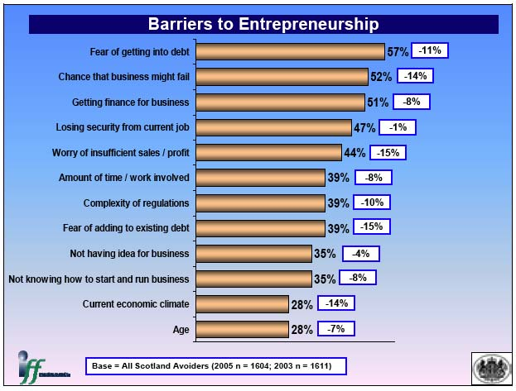
Please indicate (3) barriers to owning a personal business and explain in your own words why each is considered a barrier.
- __________________________________________________________________________________________________________________________________________________________________________________________________________________________________________
- __________________________________________________________________________________________________________________________________________________________________________________________________________________________________________
- __________________________________________________________________________________________________________________________________________________________________________________________________________________________________________

