Cold War and Containment
What hardships are the Cuban people facing because of the policy of Containment?

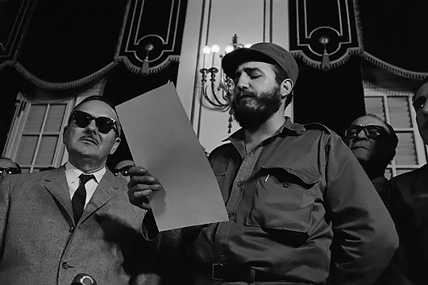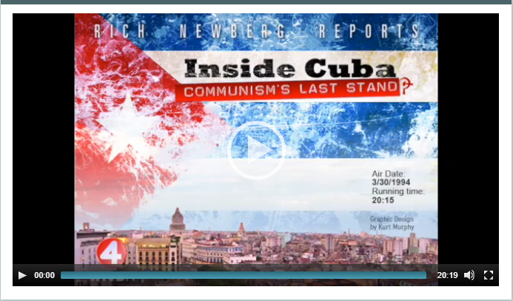

Newberg, Rich (Producer, Writer, Host), Yearke, Don (Photographer, Editor), and Musial, Chris (Executive Producer), “Inside Cuba : Communism's Last Stand?,” B&ECPL Digital Collections, accessed October 23, 2019, http://digital.buffalolib.org/document/1824.

Supporting Questions
- What impact does the United States government have when they try and shut out a government?
- What technologies and customs are impacted when a country adapts communism as their political structure?
- Did the policy of containment work in regards to Cuba?
- Since the Cold War has ended, how have countries been treated that sided with communism

Grade level Inquiry Title

Compelling Question?
Standards and Content | 11.9a After World War II, ideological differences led to political tensions between the United States and the Soviet Union. In an attempt to halt the spread of Soviet influence, the United States pursued a policy of containment.
Staging the Compelling Question | This question will spin into further polices of the United States government and the end of the Cold War.

Supporting Question 1 |  | Supporting Question 2 |  | Supporting Question 3 |  | Supporting Question 4
What types of relationships have the United States government had with the leaders of Cuba? |  | What technologies and customs are impacted when a country adapts communism as their political structure? |  | Did the policy of containment work in regards to Cuba? |  | Since the Cold War has ended, how have countries been treated that sided with the Soviet Union
Formative Performance Task |  | Formative Performance Task |  | Formative Performance Task |  | Formative Performance Task
Research the relationships that Cuba has had with USA, and what types of governments were in power at the time |  | Create a small presentation (PowerPoint, Prezi, etc..) that describes the different technology and custom that we affected. |  | Write a persuasive argument paragraph describing if the policy of containment was successful in regards to Cuba.
Featured Sources |  | Featured Sources |  | Featured Sources |  | Featured Sources
Source A: Library of Congress  http://cdn.loc.gov/service/ll/uscode/uscode1988-04402/uscode1988-044022069/uscode1988-044022069.pdf |  | Source A: Rich Newberg Reports: Inside Cuba |  | Source A:  https://guides.loc.gov/cuba-business-economy |  | Source A:  https://www.pbs.org/wgbh/americanexperience/features/castro-cuban-exiles-america/

Summative Performance Task | ARGUMENT: Construct an argument (e.g., detailed outline, poster, essay) that evaluates the hardship that the people of Cuba have faced since the policy containment was enforced by the United States government.
 | EXTENSION. Create a detailed portfolio. Present the portfolio and their beliefs in front of other students.
Taking Informed Action | UNDERSTAND: How policies have effected other nations.  ASSESS: The impact of life in smaller and poorer countries, and if American policies are to blame  ACT: have students support organizations that help people in other nations.
*Featured sources are suggested and links are provided. It may be that these links are broken and we apologize in advance for the inconvenience.

Overview

Inquiry Description
This inquiry leads students through an investigation of policies of containment and communism
This this inquiry highlights the following additional standards:
10.5d Nationalism and ideology played a significant role in shaping the period between the world wars.
10.6b The Cold War was a period of confrontations and attempts at peaceful coexistence.
11.9d A combination of factors contributed to the end of the Cold War, including American policies and Soviet economic and political problems that led to the loss of Soviet control over Eastern Europe
It is important to note that this inquiry requires prerequisite knowledge of …

Note: This inquiry is expected to take three or four 50-minute class periods. The inquiry time frame could expand if teachers think their students need additional instructional experiences (e.g., supporting questions, formative performance tasks, featured sources, writing). Teachers are encouraged to adapt the inquiry to meet the needs and interests of their students. This inquiry lends itself to differentiation and modeling of historical thinking skills while assisting students in reading the variety of sources.

Structure of the Inquiry
In addressing the compelling question …
This inquiry comes from a different perspective. This inquiry shows the effects of containment on people that are very close to our nation’s borders. It will examine how even after the war; people’s lives are still effected by older policies. We often see the policies of our government in a positive view because of our nationalist perspective. This inquiry can show how tough it is for other countries to deal with American policies, and how slow they are to change. Looking at life in a country after the Cold War is over shows how life in communist countries was centered. You can have students examine how communism works, what life is like, and why it failed compared to capitalism.

Staging the Compelling Question
In staging the compelling question, …
The compelling question relates to the Cold War and the United States policy of containment. This question is very important to see how the other side of the coin, when people are impacted by the American policies. This question will spin into further polices of the United States government and the end of the Cold War.

Supporting Question 1
The first supporting question
What types of relationships have the United States government had with the leaders of Cuba?
The formative task
Research the relationships that Cuba has had with USA, and what types of governments were in power at the time

Teachers may implement this task with the following procedures…
Students will use the link to examine the information. They will collect styles of government and leader on both sides. Describe how the relationships were at major points of Cuban and US relations.
The scaffolds and other materials may be used to support students as they work with sources…
Students can receive a paper copy, use of highlighters, graphic organizer, and key concepts are broken down or highlighted
The following sources were selected to …
- Featured Source A is …
Source A: Library of Congress
http://cdn.loc.gov/service/ll/uscode/uscode1988-04402/uscode1988-044022069/uscode1988-044022069.pdf

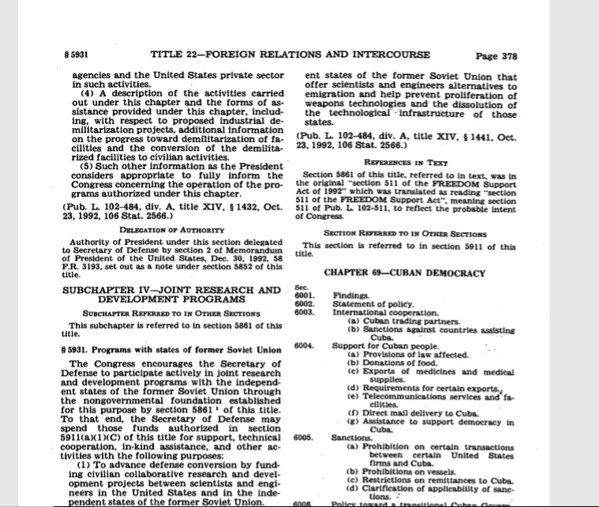 Sample View

Supporting Question 2
The first supporting question—…
What technologies and customs are impacted when a country adapts communism as their political structure?
The formative task is…
Create a small presentation (PowerPoint, Prezi, etc..) that describes the different technology and custom that we affected.
Teachers may implement this task with the following procedures…
Students will examine the Rich Newberg reports video. After watching the video, students will create a small presentation (PowerPoint, Prezi, etc.). The presentation will describe what the student saw in the video, how the different customs and technologies are different from the USA. They will compare what is seen today versus what is seen in Cuba.
The scaffolds and other materials may be used to support students as they work with sources…
Using a graphic organizer to describe what should go on each slide step by step. Students will need to incorporate pictures and transitions. A check list will be given and students will check off each item as they complete it. A rubric will also be given so students can see how many points each part is worth.
The following sources were selected to …
- Featured Source A is …
Newberg, Rich (Producer, Writer, Host), Yearke, Don (Photographer, Editor), and Musial, Chris (Executive Producer), “Inside Cuba : Communism's Last Stand?,” B&ECPL Digital Collections, accessed October 30, 2019, http://digital.buffalolib.org/document/1824.

Supporting Question 3
The first supporting question—…
Did the policy of containment work in regards to Cuba?
The formative task is…
Write a persuasive argument paragraph describing if the policy of containment was successful in regards to Cuba.
Teachers may implement this task with the following procedures…
Students will view the link to the Library of Congress. They can use any of the resources given on the site, most critically will be the Key Legislation tab. Students will write a persuasive argument whether the policy worked in regards to Cuba. They will use this source to give historical reference and information for their argument.
The scaffolds and other materials may be used to support students as they work with sources…
Students will be receiving a list of sentence starters. Students will use the Step Up to Writing process. They will state their claim and then use the information from the link for supporting details. This method will then help them complete an well-constructed paragraph.
The following sources were selected to …
- Featured Source A is …
https://guides.loc.gov/cuba-business-economy

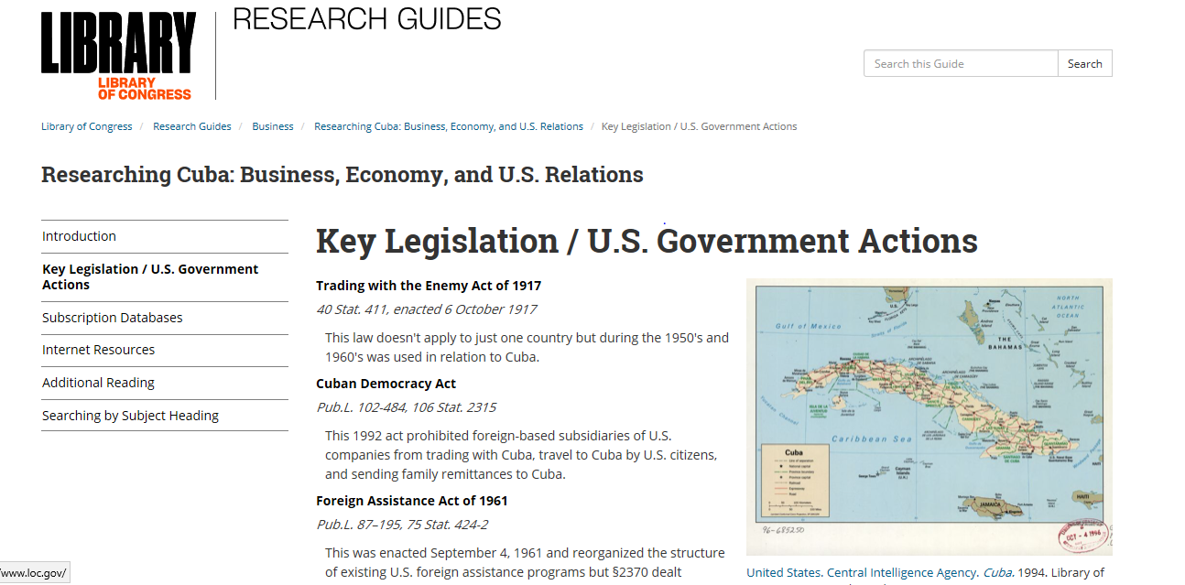Sample View

Summative Performance Task
At this point in the inquiry, students have examined …
Constructed an argument (e.g., detailed outline, poster, essay) that evaluates the hardship that the people of Cuba have faced since the policy containment was enforced by the United States government.
Students should be expected to demonstrate the breadth of their understandings and their abilities to use evidence from multiple sources to support their claims. In this task, students …
Create a detailed portfolio. Present the portfolio and their beliefs in front of other students.
Students’ arguments will likely vary, but could include any of the following:

Poverty, Lack of Technology, lack of communication with outside World (Globalization), Poor Health

To support students in their writing…
Students will receive graphic organizers, use Step-Up to Writing techniques, Sentence Starters
To extend their arguments, …
Students will create a portfolio, and give a brief presentation in front of peers on their findings.
Students have the opportunity to Take Informed Action by …
Contacting groups around the city that help people in other countries with aide and education.

