Title: The Great Depression
Compelling Question | Does the government have the duty to help the needy?
New York State Social Studies Framework Key Idea | 8.5 Great Depression: Economic and environmental disasters in the 1930s created hardships for many Americans. Amidst much debate about the appropriate role of government, President Franklin D. Roosevelt helped to create intensive government interventions in the United States economy and society. (8.5a, 8.5b, 8.5c)
Supporting Question 1 |  | Supporting Question 2 | Supporting Question 3
What economic conditions during the Great Depression made many Americans appear “needy”? |  | What environmental conditions during the Great Depressions caused many economic and personal needs in the mid- west? | Did the government’s programs do enough to fulfill the needs of all Americans?
Formative  Performance Task |  | Formative  Performance Task | Formative  Performance Task
Students will view various sources to determine the effects of the Depression and identify on a graphic organizer groups or situations in which Americans were considered to be “needy” by completing a paragraph writing assignment. |  | Students will view various photographs, a video, and read the song lyrics of Woody Guthrie. Student will create a song, poem or visual describing the conditions and impact of the Dust Bowl. | Support the argument by viewing various New Deal Program posters and text based descriptions. Students will then rank the posters in order of significance or impact on the needy.
Featured Sources |  | Featured Sources | Featured Sources
Photograph of a “Hooverville/  “Shanty town”(Homeless)  “Migrant Mother, by  Dorothea Lange  “Unemployment” by  Ben Shahn  Frederick Lewis Allen,  Book excerpt from Since Yesterday  Ruth Poterfield, “Women Available” The Mercury |  | “Dust Storm Disaster” & “Dust Bowl Blues”  History Channel web source  The Dust Bowl damage map | Excerpt from F.D.R. Inaugural address (1933)  Social Security Administration Poster  F.D.R. Political Cartoon, medicine to heal Uncle Sam
Summative  Performance Task | Develop a New Deal Posters displaying the most important aspect/plan that helped the needy during the Great Depression. Write a short response with evidence defending your choice.
Taking Informed Action | Students will analyze the economic crisis of 2009 and research the rise of pop up tent cities across America. Students will read an article from the New York Times and write a letter to the President. In the letter students will identify the problem and determine if Governmental assistance is requested.

Taking Informed Action Sources:

http://www.nytimes.com/2009/03/26/us/26tents.html

https://www.youtube.com/watch?v=yz8LXq1q6iI

By asking the compelling question “Does the government have the duty to help the needy?” students take on a topic with a long history and plenty of relevance for today. The inquiry prompts students to identify groups affected by the depression and programs initiated to support the “needy”.

Students examine a wide range of historical sources while focusing on questions concerning the extent to which government should take care of its people. In addition to the Key Idea listed earlier, this inquiry highlights the following Conceptual Understanding: . This inquiry is expected to take 5-6 40-minute class periods. 8.5 Great Depression: Economic and environmental disasters in the 1930s created hardships for many Americans. Amidst much debate about the appropriate role of government, President Franklin D. Roosevelt helped to create intensive government interventions in the United States economy and society. (8.5a, 8.5b, 8.5c)

http://digitalcollections.lib.washington.edu/cdm/singleitem/collection/lee/id/83
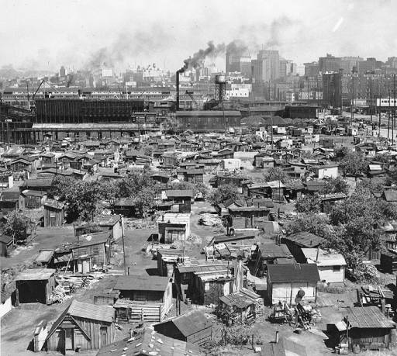

http://loc.gov/pictures/resource/fsa.8b29516/

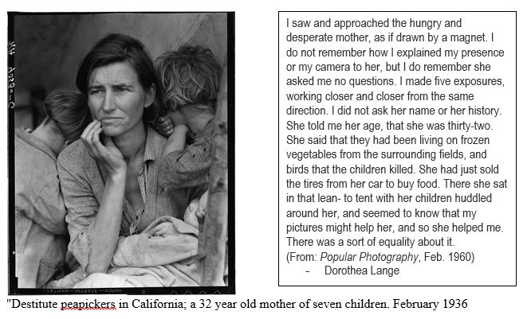

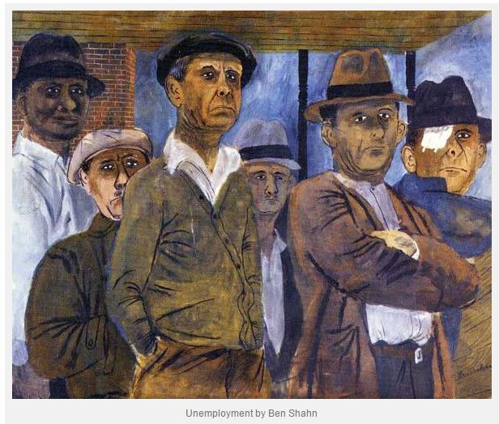

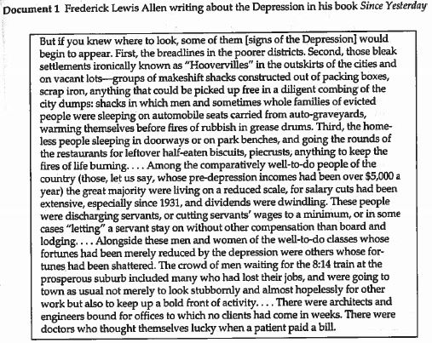

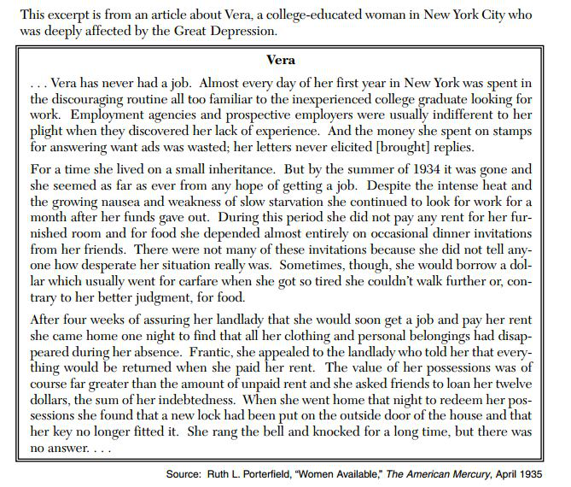

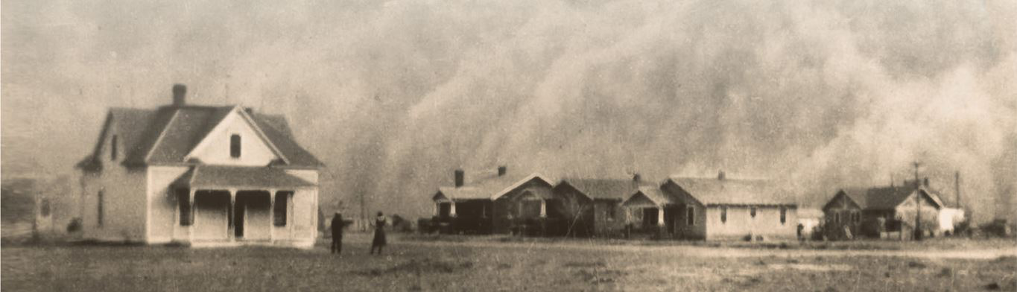
http://www.pbs.org/kenburns/dustbowl/photos/

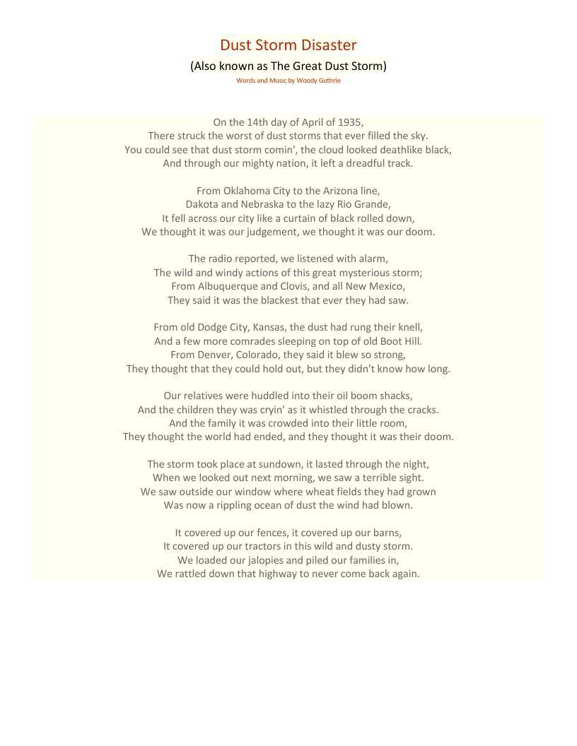

Supporting Question #3 Resources:

http://www.presidency.ucsb.edu/ws/?pid=14473

The American Presidency Project:

Happiness lies not in the mere possession of money; it lies in the joy of achievement, in the thrill of creative effort. The joy and moral stimulation of work no longer must be forgotten in the mad chase of evanescent profits. These dark days will be worth all they cost us if they teach us that our true destiny is not to be ministered unto but to minister to ourselves and to our fellow men.
Recognition of the falsity of material wealth as the standard of success goes hand in hand with the abandonment of the false belief that public office and high political position are to be valued only by the standards of pride of place and personal profit; and there must be an end to a conduct in banking and in business which too often has given to a sacred trust the likeness of callous and selfish wrongdoing. Small wonder that confidence languishes, for it thrives only on honesty, on honor, on the sacredness of obligations, on faithful protection, on unselfish performance; without them it cannot live. Restoration calls, however, not for changes in ethics alone. This Nation asks for action, and action now.
Our greatest primary task is to put people to work. This is no unsolvable problem if we face it wisely and courageously. It can be accomplished in part by direct recruiting by the Government itself, treating the task as we would treat the emergency of a war, but at the same time, through this employment, accomplishing greatly needed projects to stimulate and reorganize the use of our natural resources.
http://www.loc.gov/pictures/item/acd1996000384/PP/
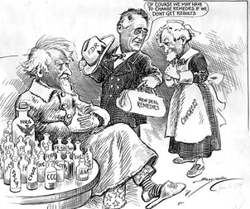

New Deal Slide Show:
http://www.history.com/topics/new-deal/pictures/new-deal-programs/wpa-road-construction-project

