4th Grade
How did the Erie Canal transform a town into a thriving city?
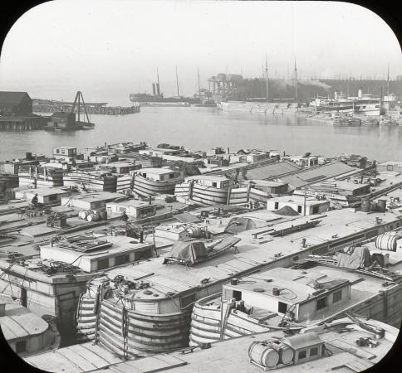

Supporting Questions
- What did the Erie Canal provide to people in the Buffalo community?
- How was the Canal an improvement over previous methods of transportation? How were later means of transportation an improvement over the Canal?
- How does the legacy of the Erie Canal affect Buffalo today?

4th Grade Geography Inquiry
How did the Erie Canal transform a town into a thriving city?

New York State Social Studies Framework Key Ideas & Practices | 4.6c Improved technology such, as the steam engine and the telegraph made transportation and communication faster and easier. Later developments in transportation and communication technology had an effect on communities, the State, and the world.  Students will investigate which early means of transportation were used in their local community and to which communities they were linked, noting why they were linked to those communities.  Students will trace developments in transportation and communication technology from the 1800s to the present, noting the effects that these changes had on their communities, the State, and the world  Gathering, Using, and Interpreting Evidence Comparison and Contextualization  Economics and Economic Systems Geographic Reasoning
Staging the  Question | Homework: Students will complete the attached Canal Packet for homework prior to the IDM lessons in order to build background. A day will be spent reviewing the packet and answering questions that students may have prior to the IDM lessons.  Brainstorm the relationship between the Erie Canal and the growth of Buffalo, New York.

Supporting Question 1 | Supporting Question 2 | Supporting Question 3
1. What did the Erie Canal provide to people in the Buffalo community? | 2. How was the Canal an improvement over previous methods of transportation? How were later means of transportation an improvement over the Canal? | 3. How does the legacy of the Erie Canal affect Buffalo today?
Formative  Performance Task | Formative  Performance Task | Formative  Performance Task
1. Have students complete “See/Think/Wonder” charts for each of the following pictures. Guide students to determine what people are shown in each picture, or what people were needed to construct what is shown in each picture.  2. Complete one of the following activities in a group.  -Create an advertisement/job posting for career opportunities on the Erie Canal.  -Create an advertisement for a business along the canal route (Saloon, restaurant, blacksmith, laundry...) | Students will examine price charts before and after the canal. They will create two Venn Diagrams comparing the Erie Canal with past and present modes of transportations. | Students will create an itinerary for a visit to historical sites in Buffalo. They will visit various websites that deal with canal tourism and create a poster that details the day.
Featured Sources | Featured Sources | Featured Sources
Source A: 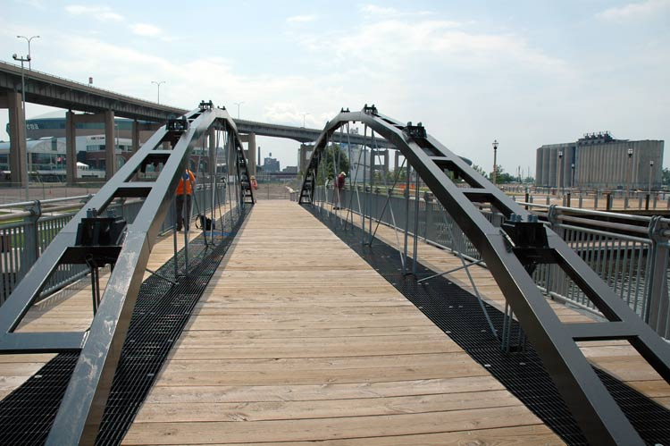  Picture of Whipple Bridge from  The New York State Archives. Students will extrapolate that engineers were needed for the canal.  Source B.  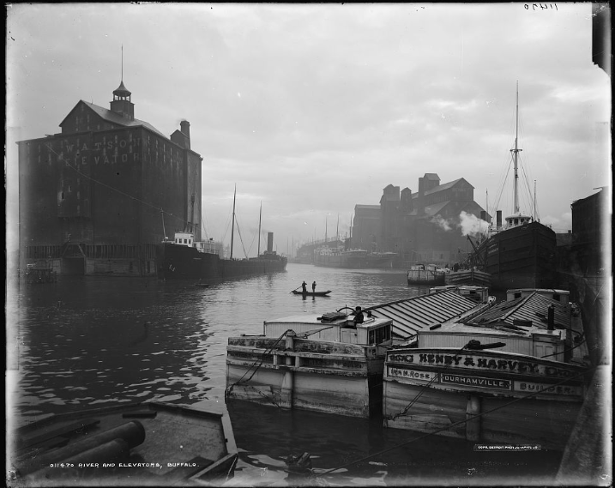  Picture of grain elevators from Library of Congress  Students will point out the people on the boat and the elevator and discuss how various jobs were created. (Grain elevator workers)  Source C  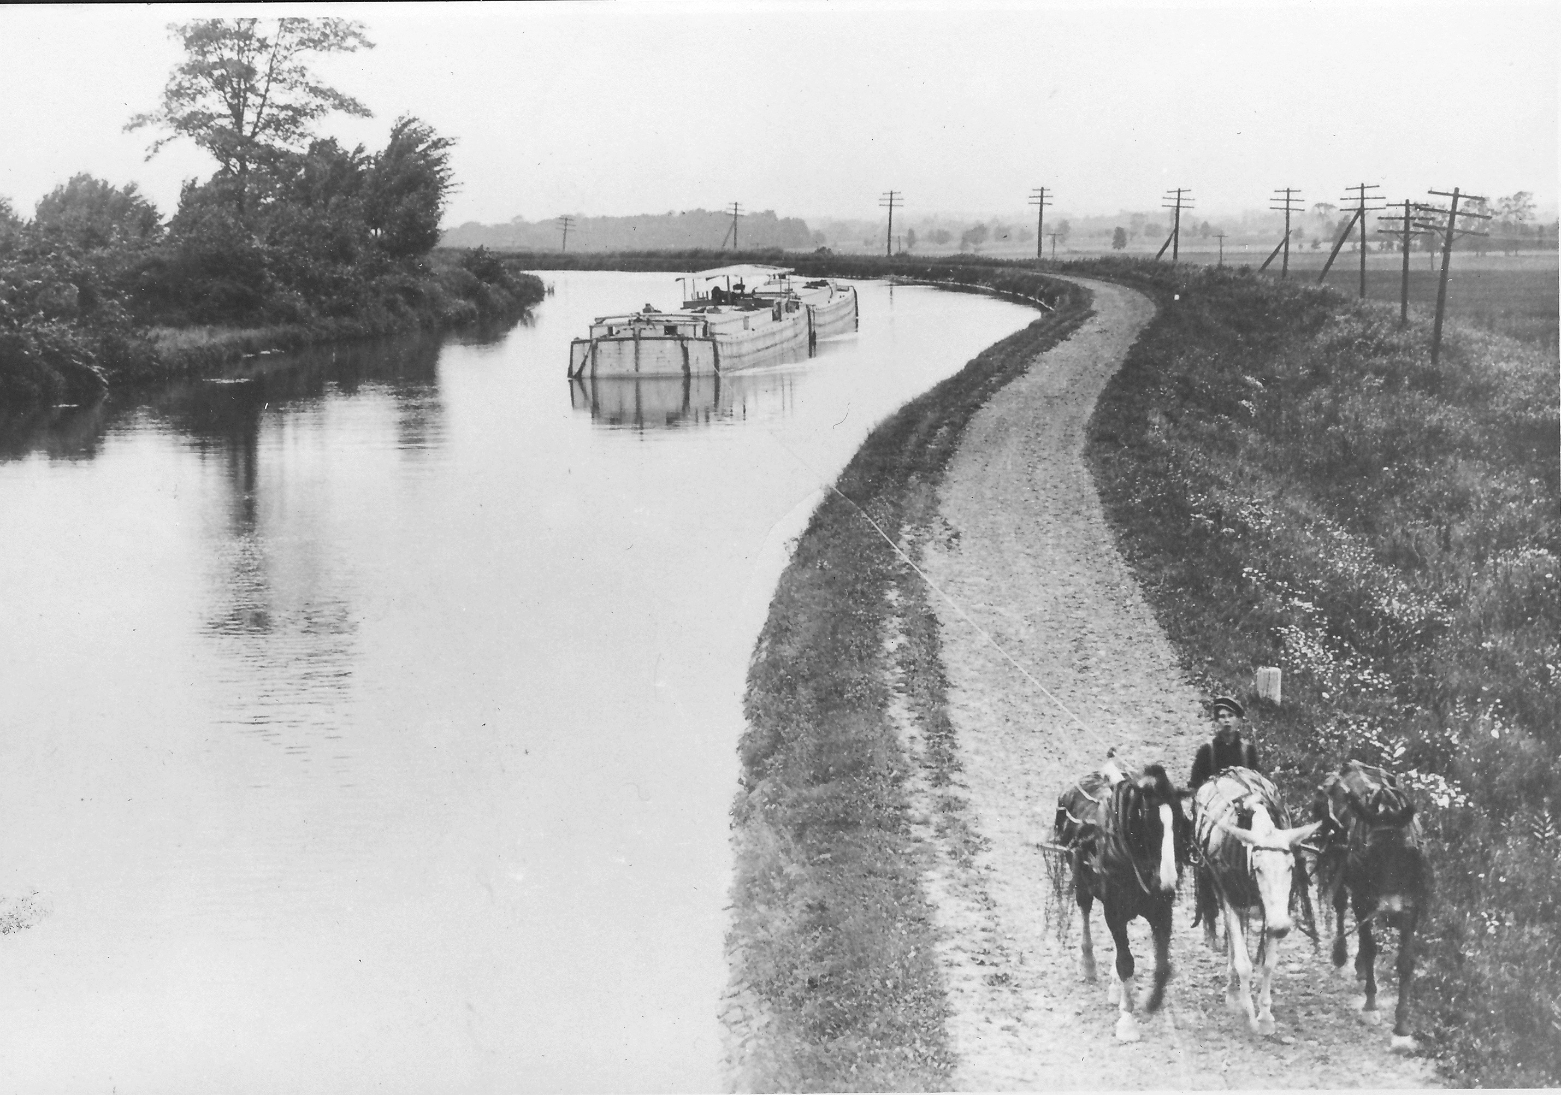  Picture of Erie Canal  http://middleport-newyork.com/middleport-grows-with-erie-canal  Students will look for the person within the image and describe his job, a Hogie.  Source D  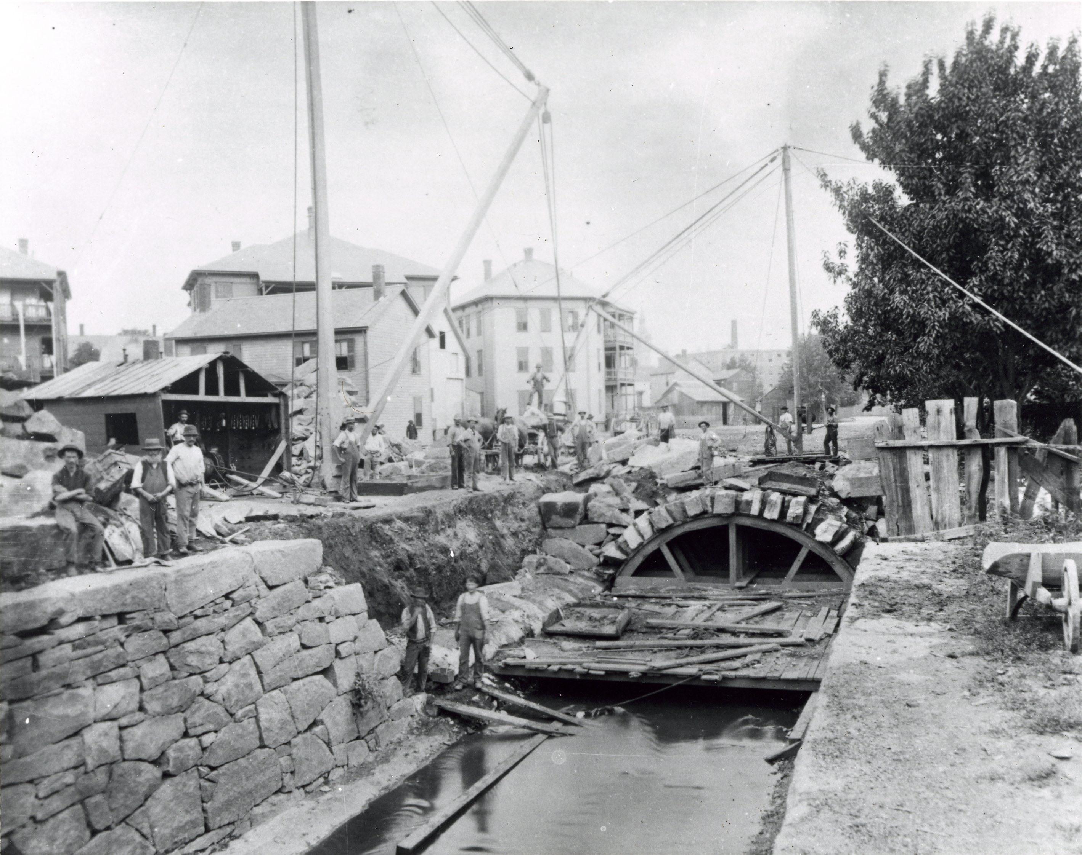  Picture of men working on the canal  http://worcestermag.com/2014/03/06/worcesters-irish-roots/21496  Students will extrapolate that people were needed to dig the canal and then move the rocks, all types of physical labor. The teacher will also lead students to notice the buildings near the canal and start brainstorming what businesses would spring up near a canal and why. | Source A: 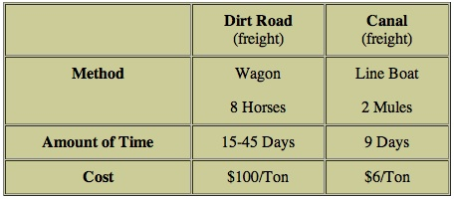  Source b.  www.catskillarchive.com/  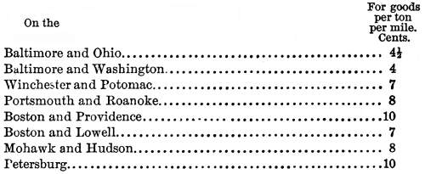  Source C.  Pictures of transportation  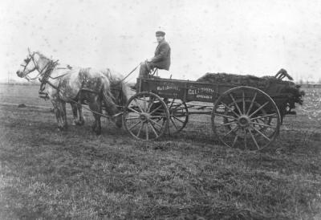  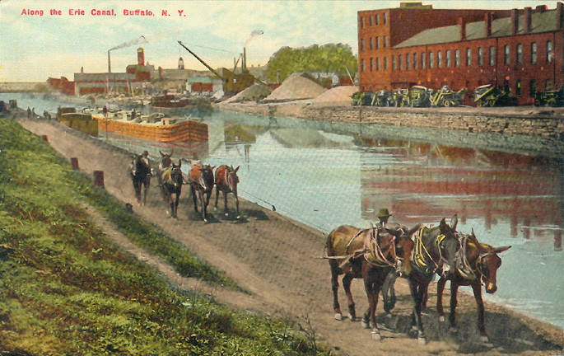  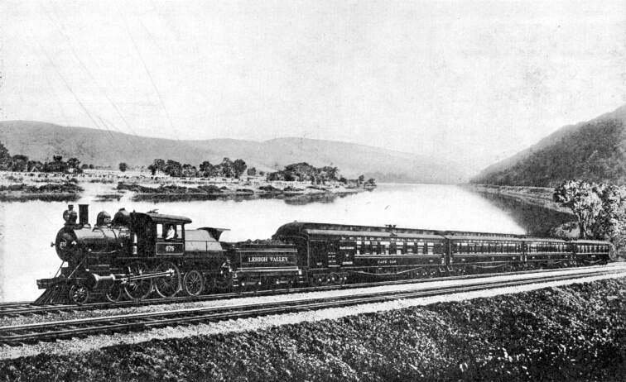 | Sources:  Websites dealing with local canal tourism.  https://www.canalsidebuffalo.com/things-to-do/  http://www.lockportlocks.com/cruiseexp.php  http://www.friendsofthebuffalostory.org/canalside.html  http://explorebuffalo.org/regularly-scheduled/silo-city-grounded/  http://www.waterfrontmemoriesandmore.com/index.cfm?lts=160126141541

Summative Performance Task | Argument “The Erie Canal had an enormous influence on the history of Buffalo. It also has an influence on the resurgence of Buffalo today.” Students will use this as a claim and complete a claim evidence chart to prove that the statement is true.
 | Extension Students will listen to various Erie Canal narratives. They will design a marker to honor one of the people from the narratives. They can make sample marker using art supplies or the computer. Examples of markers are included in the addendum.
Taking Informed Action | Understand Students will discuss how people in a community can take informed action and how people can and should be able to make changes within their community.  Assess Students will view the completed markers. They will vote on which marker is the best.  Act Students will send letters to area representatives with news of their marker contest and information that they learned within the class. .

Overview

Inquiry Description

Students will look at a variety of sources in order to answer questions about the Erie Canal. They will learn how the canal was an improvement over previous methods of transportation and how the canal affected the growth of Buffalo. This will be a chance for students to become involved in local history and current events.

Content Background

This IDM will focus on introducing new technology (canal) and how it made transportation and communication faster and easier. Students will investigate how the canal was used in their local community. They will note why they were linked to Buffalo and how the Canal changed the area. Students will trace developments in transportation technology from the 1800s to the present, noting the effects that these changes had on their communities. Teachers will build background by having students complete a homework packet on the Erie Canal. The packet is included in the IDM addendum

Students will
At the end of the IDM lesson, students will create an itinerary for a visit to historical sites in Buffalo. They will visit various websites that deal with canal tourism and create a poster that details the day. This is in addition to various formative assessments that students will complete throughout the multi-day lesson.

Content, Practices, and Literacies

A robust curriculum inquiry marries the key content students need to learn and the social studies practices they need to learn and master. The formative performance tasks in this inquiry build students’ content knowledge of local history as they apply social studies practices to learn how Buffalo was affected by the Erie Canal. The first formative performance task focuses students’ attention on identifying the jobs and businesses created by the Erie Canal. The second formative performance task introduces prior methods of transportation to have students compare past and present modes of transportation. The third formative performance task highlights the ways people in Buffalo today interact with the legacy of the Erie Canal. In order to do so, students add the practice of Economics and Economic Systems to the accumulating practices of Gathering, Using, and Interpreting Evidence, and Comparison and Contextualization.
Evident across the three formative performance tasks is an increasing complexity of thinking. The first task works at the identification level in that students are identifying the jobs and businesses created the Canal. The second task also has a comparison element in that students are asked to compare and contrast different forms of transportation. In the third task, students move to the interpretation of evidence by making and supporting claims about how the canal affects Buffalo today.
The New York State P–12 Common Core Learning Standards for English Language Arts & Literacy offer social studies teachers numerous opportunities to integrate literacy goals and skills into their social studies instruction. The Common Core supports the inquiry process through reading rich informational texts, writing evidence-based arguments, speaking and listening in public venues, and using academic vocabulary to complement the pedagogical directions advocated in the New York State K–12 Social Studies Framework. At the end of this inquiry is an explication of how teachers might integrate literacy skills throughout the content, instruction, and resource decisions they make.

Supporting Question 1
Supporting Question | 1. What did the Erie Canal provide to people in the Buffalo community?
Formative Performance Task | -Create an advertisement/job posting for career opportunities on the Erie Canal.  -Create an advertisement for a business along the canal route (Saloon, restaurant, blacksmith, laundry...)
Featured Sources | Source A: Picture of Whipple Bridge from  The New York State Archives. Students will extrapolate that engineers were needed for the canal.  Source B: Picture of grain elevators from Library of Congress  Source C: Picture of Erie Canal  http://middleport-newyork.com/middleport-grows-with-erie-canal  Source D: Picture of men working on the canal  http://worcestermag.com/2014/03/06/worcesters-irish-roots/21496
Conceptual Understanding | Define and frame questions about the United States that can be answered by gathering, interpreting, and using evidence.  Identify, select, and evaluate evidence about events from diverse sources (including written documents, works of art, photographs, charts and graphs, artifacts, oral traditions, and other primary and secondary sources).  1. Explain how scarcity necessitates decision making; compare the costs and benefits of economic decisions
Content Specifications | Students will be able explain how the Erie Canal created jobs and businesses within the Buffalo area.
Social Studies Practices | Gathering, Interpreting and Using Evidence  E. Economics and Economic Systems

Supporting Question
As students begin to think about and investigate this supporting question and the featured sources, they will explore local history and understand the importance of the Erie Canal. The images from Buffalo will offer insight into the importance of the Canal to local history.

Formative Performance Task
The formative performance task is to create an advertisement for jobs or businesses. Students will be able to use a Microsoft program such as Publisher to create the advertisement. They will present the ads to the class and students will be able to see how many jobs and businesses were created as a result of the Erie Canal.

Supporting Question 2
Supporting Question | 1. 2. How was the Canal an improvement over previous methods of transportation? How were later means of transportation an improvement over the Canal?
Formative Performance Task | Students will examine price charts before and after the canal. They will create two Venn Diagrams comparing the Erie Canal with past and present modes of transportations.
Featured Sources | Source A: Chart of canal prices  Source B: Graph of canal prices  Source C: Pictures of transportation methods
Conceptual Understanding | Describe, compare, and evaluate multiple historical developments within the United States in various chronological and geographical contexts.
Content Specifications | Students will be able to compare and contrast various methods of transportation.
Social Studies Practices | Comparison and Contextualization

Supporting Question 3
Supporting Question | 3. How does the legacy of the Erie Canal affect Buffalo today?
Formative Performance Task | Students will create an itinerary for a visit to historical sites in Buffalo. They will visit various websites that deal with canal tourism and create a poster that details the day.
Featured Sources | Sources:  Websites dealing with local canal tourism.  https://www.canalsidebuffalo.com/things-to-do/  http://www.lockportlocks.com/cruiseexp.php  http://www.friendsofthebuffalostory.org/canalside.html  http://explorebuffalo.org/regularly-scheduled/silo-city-grounded/  http://www.waterfrontmemoriesandmore.com/index.cfm?lts=160126141541
Conceptual Understanding | Describe, compare, and evaluate multiple historical developments within the United States in various chronological and geographical contexts.
Content Specifications | Develop the connections of an interdependent community by engaging in the political process as it relates to a local context.
Social Studies Practices | Civic Participation

Taking Informed Action
Compelling Question | Does where you live matter?
Taking Informed Action | Understand Brainstorm a list of the geographic opportunities and constraints in area neighborhoods and communities.  Assess Discuss how individuals and communities can turn constraints into opportunities.  Act Arrange for a local official to visit the class to review the class conclusions and discuss possible community actions.

Building Background:
Students should complete this packet prior to starting the IDM lesson plans.
http://www.canals.ny.gov/history/activitybook2006.pdf

